Large Scale EVS: World Cup Volunteers 2015
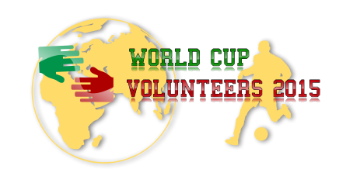
Date: 24/06/15 – 09/07/15
Place: Castelfranco Emilia
Project activities: The volunteers will take part to the whole organisation and to the implementation of the festival, in particular in logistics and practical aspects (cleaning, helping in the kitchen, arranging festival spaces). They will have the possibility to take part to various activities, such as tournaments of several sports, outdoor activities, debates related to antidiscrimination, concerts…
The project “World cup volunteers 2015” will also include the following activities:
- On-arrival and integration training
- Intensive language training
- Event management workshop
- Social media and website workshop
- Dissemination workshop
- The Conference “Volunteers on move: take your chance!”
- The Conference “Volunteering: the hidden value”

Name:
Surname:
Date of birth:
Gender:
In which country/city do you live?
Email address:
Mobile number (including prefix):

English level:
- Beginner ☐
- Intermediate ☐
- Good ☐
- Fluent ☐
Other languages spoken:
Introduce yourself in a few words:

Hobbies, personal interests:

Interest for the topics (sport, festival, volunteering…) and previous experiences:

Previous international experiences:

Why do you want to take part in this project?

Special diet or allergies:

Emergency contact:

Anything else you would like to tell us?

